7.21: a) In this situation, 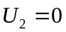 when 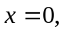 so 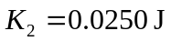 and 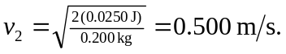 b) If 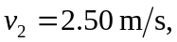 so 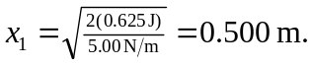 Or, because the speed is 5 times that of part (a), the kinetic energy is 25 times that of part (a), and the initial extension is 